Experiment Number 4

* Write a shell script that determines the period for which a specified user is working on the system.

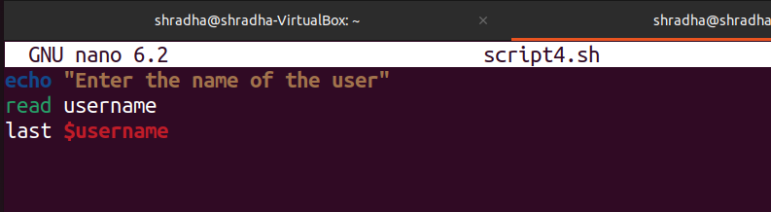

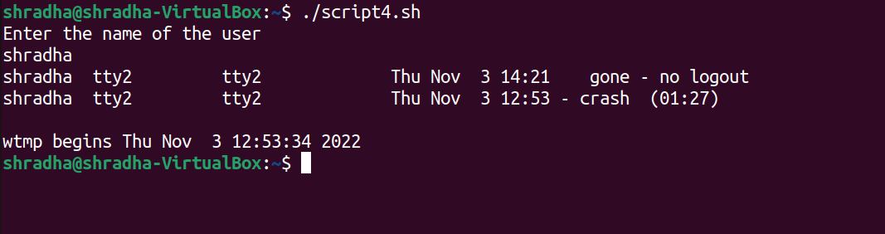

* Write a shell script that displays all the lines between string and end line numbers passed as argument.

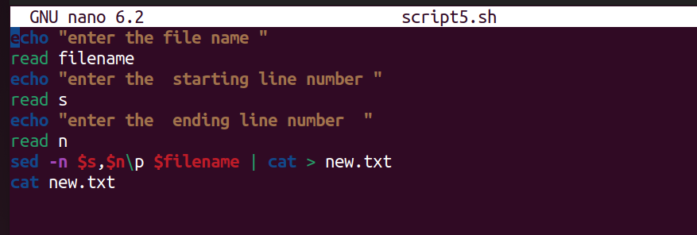

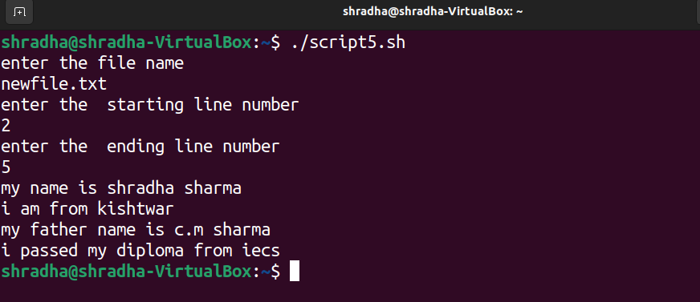

* Write a shell script that deletes all lines containing a specified word in one of more files supplied as arguments to it

